Making a .png file using Google Maps

- Because we use GPS to localize the tractor we use the gps_odom.py program to translate lat/lon into an odom statement. This program uses a reference point (a.k.a. an origin) to calculate the x, y position from that origin. Choose a point to be the origin and capture the lat/lon of that point.
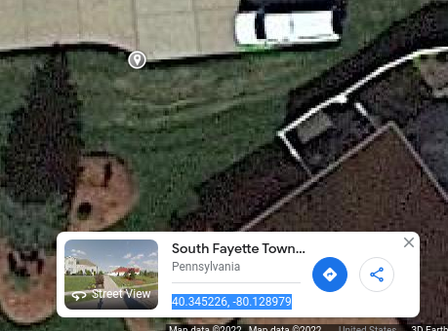

For example I am going to refer to this corner in the concrete because I can see it plainly and the x, y coordinates will normally be positive. I checked what Google had for the point, but for inputing into the program I used the RTK GPS position from the fix topic.

Lat 40.345245345; Lon -80.128990477

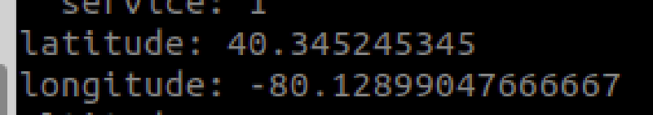

- Decide where you want to begin the lower left corner of the screen capture
- Make note of that lat/lon. We may use it later to help calculate the origin
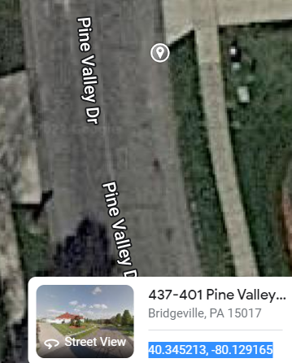

- Take a screen print of the location in Google Maps
- 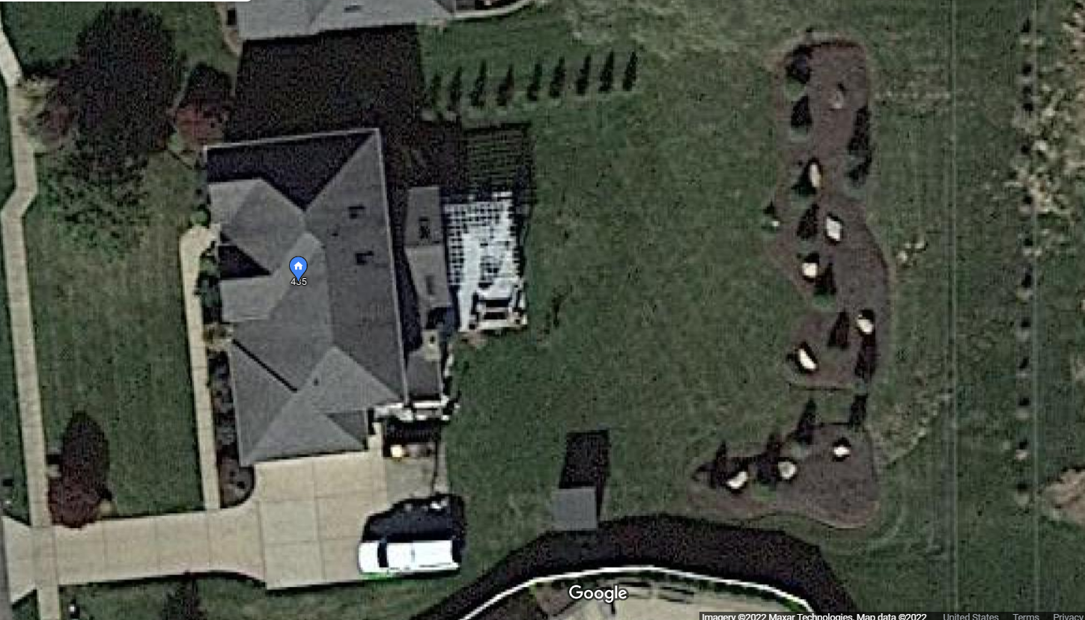
- Save that image to be traced
- I saved the clip into OneNote and then saved the image as 435_Pine_Valley.png
- As best you can, use Google Map measuring device to determine the width of the property you captured in the image
- 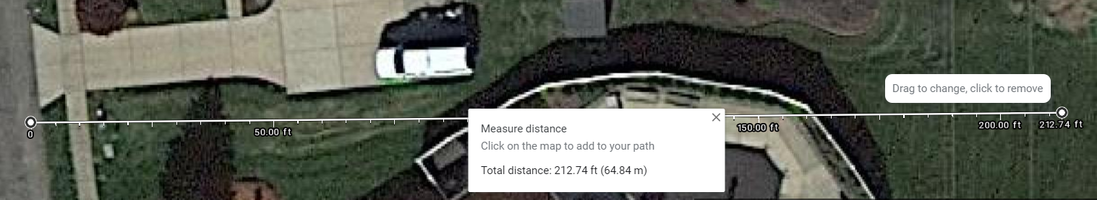
- We need to figure out the origin and resolution. Resolution is the ratio of pixels to meters.
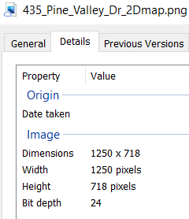 | - 212.74 feet  - 212.74ft X .3048 = 64.84315m  - 64.84315 (meters) /1250 (pixels) = 0.05187452  - Resolution = 0.05187452
- In PowerPoint, Import the .png file
- Use boxes and highlighter in black to outline no-go areas. I started with thick lines around the edges.
- 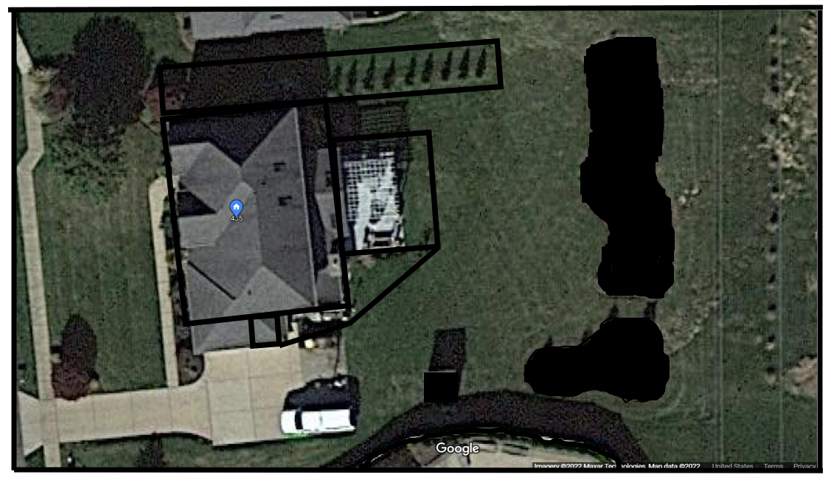
- In PowerPoint Copy slide to a new slide
- Delete the satelitte image from the slide
- 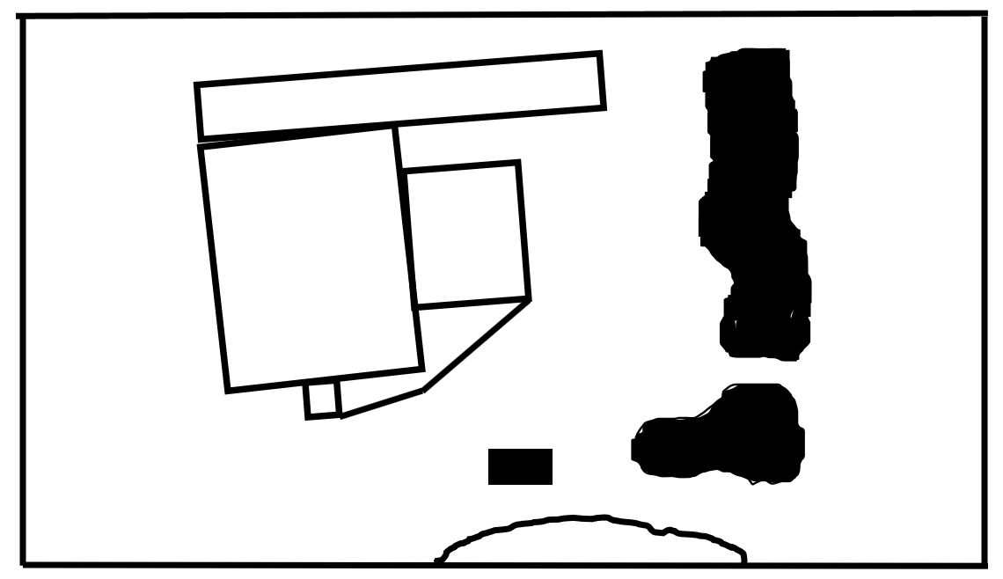

Copy .png file into the map folder
Update .yaml file with name of file and resolution calculated above (i.e. 0.05187452)
Determine the lower left position in x, y meters for the origin statement (origin tag in the yaml)
Change the statement below in ros1_nav.launch for the map server
args="$(find lawn_tractor_sim)/maps/farm.yaml" output="screen">

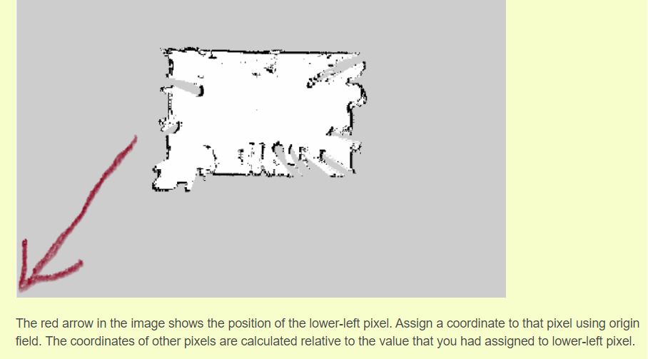
Ref: https://answers.ros.org/question/322919/to-understand-the-concept-of-origin-field-from-map_server/

origin : The 2-D pose of the lower-left pixel in the map, as (x, y, yaw), with yaw as counterclockwise rotation (yaw=0 means no rotation). Many parts of the system currently ignore yaw. link

Original:
#changes by sam
image: ros_farm_v01.png
resolution: .1
origin: [-30.0, -30.0, 0.0]
negate: 0
occupied_thresh: 0.65
free_thresh: 0.196
Updated:
image: 435_pine_valley_rviz.png
resolution: 0.05187452
# [x, y, z] x appears to be East/West; y is North/South
origin: [-26.0, -14.0, 0.0]
negate: 0
occupied_thresh: 0.65
free_thresh: 0.196

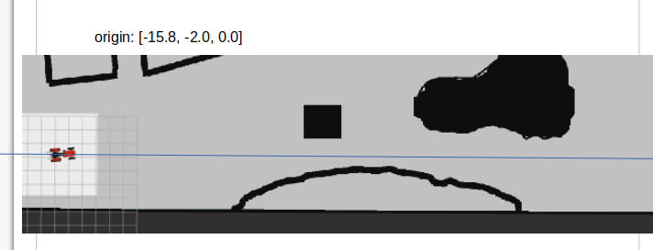

I tried multiple settings until I was happy. I copied the RVIZ image into a slide and added the blue line to see if I liked the position.

I have not tried it, but this offers a .py script that will input a .png file and using input parameters it will generate a .yaml and .pgm file.
https://www.youtube.com/watch?v=ySlU5CIXUKE
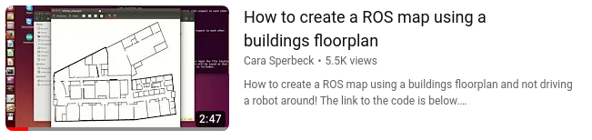

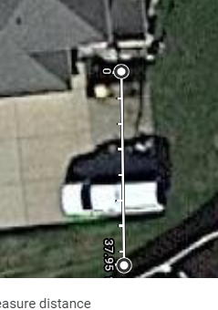 | 